Layer 3 Switch

🌐 What is a Layer 3 Switch?
# Source: Chatgpt (GPT‑5 Mini) at [12/18/2025]
A Layer 3 Switch is a network switch that combines the speed of a Layer 2 switch with the routing capabilities of a router. It operates at both:
- Layer 2 (Data Link Layer) — for switching using MAC addresses
- Layer 3 (Network Layer) — for routing using IP addresses
So, a Layer 3 switch can switch traffic within VLANs and also route traffic between VLANs or subnets, without needing a separate router.

🧠 Why It Matters
# Source: Chatgpt (GPT‑5 Mini) at [12/18/2025]
In large or segmented networks, you often need to:
- Keep traffic isolated (e.g. between departments)
- But still allow controlled communication (e.g. HR talking to IT)
A Layer 3 switch makes that possible, without bottlenecks from a traditional router.

🔧 Key Features of a Layer 3 Switch
# Source: Chatgpt (GPT‑5 Mini) at [12/18/2025]
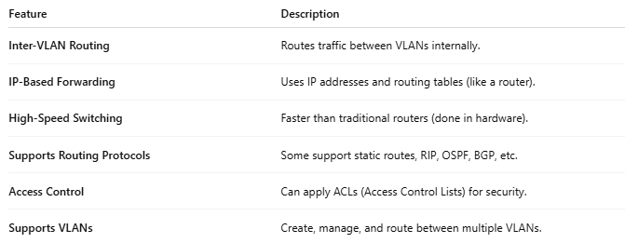

Feature | Description
Inter-VLAN Routing | Routes traffic between VLANs internally.
IP-Based Forwarding | Uses IP addresses and routing tables (like a router).
High-Speed Switching | Faster than traditional routers (done in hardware).
Supports Routing Protocols | Some support static routes, RIP, OSPF, BGP, etc.
Access Control | Can apply ACLs (Access Control Lists) for security.
Supports VLANs | Create, manage, and route between multiple VLANs.

🖥️ Example Network Setup
# Source: Chatgpt (GPT‑5 Mini) at [12/18/2025]
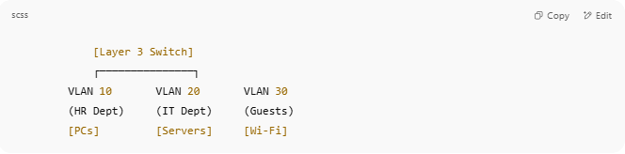
[Layer 3 Switch]
┌───────────────┐
VLAN 10 VLAN 20 VLAN 30
(HR Dept) (IT Dept) (Guests)
[PCs] [Servers] [Wi-Fi]

- All VLANs are isolated
- Layer 3 switch routes between them, with rules controlling what’s allowed

🆚 Layer 2 vs Layer 3 Switch
# Source: Chatgpt (GPT‑5 Mini) at [12/18/2025]
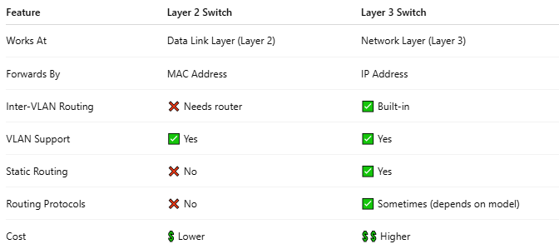

Feature | Layer 2 Switch | Layer 3 Switch
Works At | Data Link Layer (Layer 2) | Network Layer (Layer 3)
Forwards By | MAC Address | IP Address
Inter-VLAN Routing | ❌ Needs router | ✅ Built-in
VLAN Support | ✅ Yes | ✅ Yes
Static Routing | ❌ No | ✅ Yes
Routing Protocols | ❌ No | ✅ Sometimes (depends on model)
Cost | 💲 Lower | 💲💲 Higher

✅ Pros of Layer 3 Switches
# Source: Chatgpt (GPT‑5 Mini) at [12/18/2025]
- ✔ High-speed inter-VLAN routing
- ✔ Reduces need for separate routers
- ✔ Improves network performance
- ✔ Great for campus, enterprise, and data center networks
- ✔ Often includes redundancy, QoS, and security controls

❌ Cons
# Source: Chatgpt (GPT‑5 Mini) at [12/18/2025]
- ❗ More expensive than basic Layer 2 switches
- ❗ Not all Layer 3 switches support advanced routing protocols
- ❗ Can be overkill for small networks

📦 Common Brands & Examples
# Source: Chatgpt (GPT‑5 Mini) at [12/18/2025]


Brand | Layer 3 Switch Models
Cisco | Catalyst 9300, 9500
Juniper | EX4300, QFX Series
HP/Aruba | 2930F, 5400R
Netgear | ProSAFE L3 models
MikroTik | CRS series (some L3 features)

